REGISTRATION FORM FOR PARTICIPANTS OF THE VII INTERNATIONAL FASCINATION OF PLANTS DAY-2024 IN UKRAINE

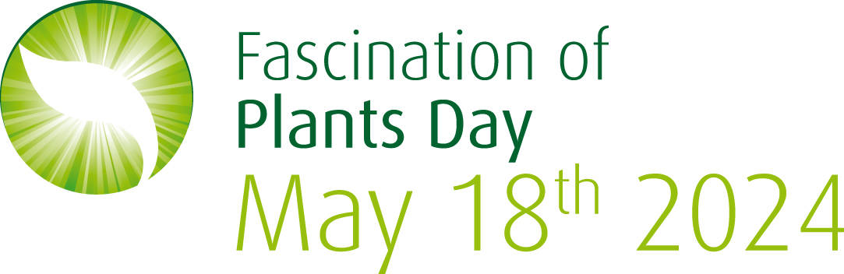

VII International Fascination of Plants Day (FoPD) is a traditional volunteer-educational event initiated by the European Plant Science Organization (EPSO) to highlight the importance of various areas of plant science in addressing global challenges. FoPD is celebrated once every two years, and this year, the official celebration will take place on May 18, 2024. However, different events can be organized throughout the whole month of May, even before and after that. Since 2012, FoPD has evolved into a global movement, engaging communities worldwide in activities that promote an appreciation for the diverse world of plants.
We are pleased to notify that Ukraine was among the top 5 countries in the world taking into account the number of activities organized in 2017 (79 events) and 2015 (127 events) in frames of FoPD.
The events of last years in Ukraine for the Fascination of Plants Day are available at the links https://plantday18may.org/category/europe/ukraine/ and https://www.facebook.com/fopd.ukraine/.

To organize an event for the Day of Plants, please fill in the registration form.
1.Title and short descriptions of the FoPD Event: 3-5 sentences
2. Event format: open day, guided tour, hands on activities, presentation, exhibition, seminar or lecture, joint meeting, artistic workshop and other forms of activity
3. Day and Time:_/05/ 2024, __:___ (AM or PM, local time)
4. Place: including actual postal address (for city events), GPS coordinates (for outdoor events).
5. Internet link to the event: (not necessary)
6. Target audience: everybody, students, families with kids, scientists, tutors, florists, entrepreneurs, landscape designers
7. Organizer(s): name, affiliations, contacts (cell phone, e-mail and/or personal page)
10. Tips for visitors: e.g., prepare rain coats and repellents/take colour crayons and scissors
Please, attach an .jpg emblem, coat of arms or trademark of your Organisation to your letter as a separate file
Our groups in Facebook:

Our hashtags for social media:

#PlantDayUkraine, #Дні_науки_Весна, #fopd, #День_рослин_Україна, #розумні

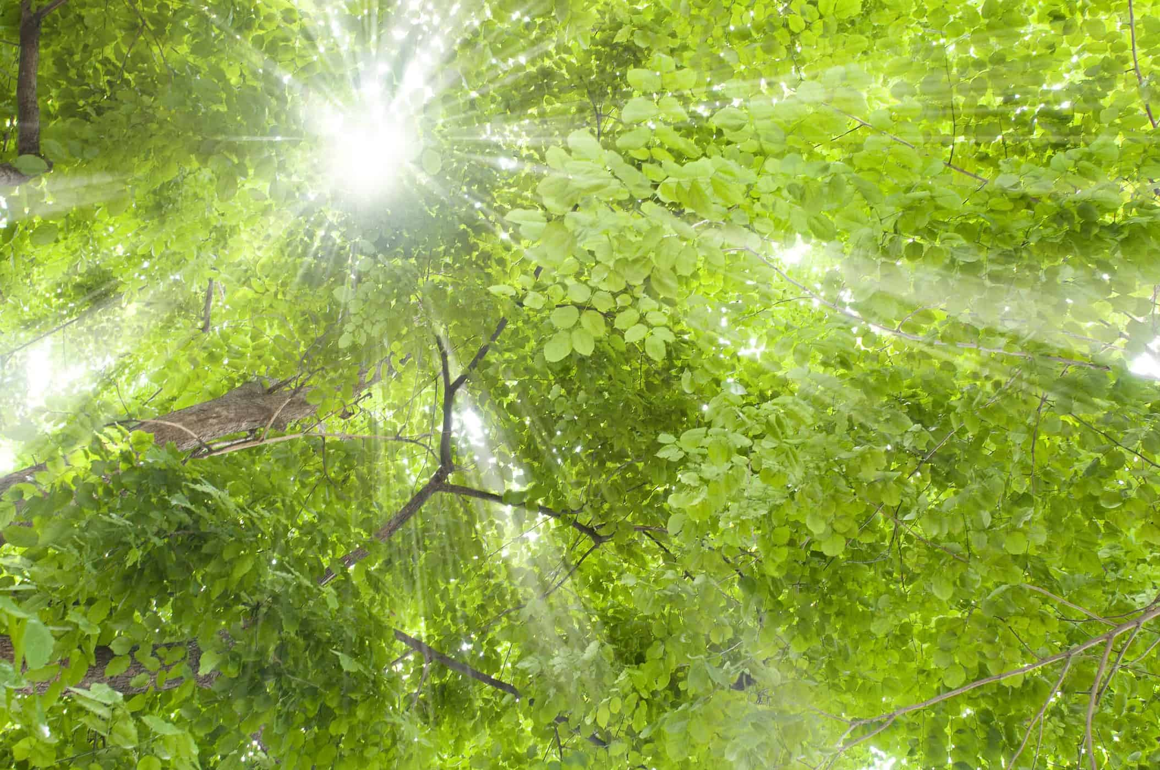

Let plants fascinate you!

