REGISTRATION FORM FOR PARTICIPANTS
of the 6th INTERNATIONAL FASCINATION OF PLANTS DAY-2022
IN UKRAINE

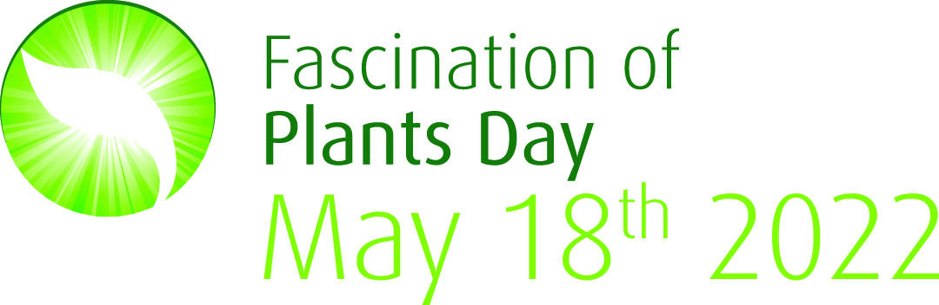

6th International Fascination of Plants Day (FoPD) − traditional volunteer educational event celebrated in Ukraine and in the world every two years under the umbrella of the European Plant Science Organisation (EPSO). This year's many events will be held in different regions of Ukraine on 18th of May, but events can be organised throughout the whole month of May, even before and after that.
We are pleased to notify that Ukraine was among the top 5 countries in the world taking into account the number of activities organized in 2017 (79 events) and 2015 (127 events) in frames of FoPD.
The events of last years in Ukraine for the Fascination of Plants Day are available at the links https://plantday18may.org/category/europe/ukraine/ and https://www.facebook.com/fopd.ukraine/.
On the back of this coordinated activity we hope to plant again many virtual and constantly germinating seeds in the collective mind of the public that plant science is of critical significance to the social and environmental landscape now and in future.

Please, indicate the format of your participation in the registration form below.
1.Title and short descriptions of the FoPD Event: 3-5 sentences
2. Event format: open day, guided tour, hands on activities, presentation, exhibition, seminar or lecture, joint meeting, artistic workshop and other forms of activity
3. Day and Time:_/05/ 2017, __:___ (AM or PM, local time)
4. Place: including actual postal address (for city events), GPS coordinates (for outdoor events).
5. Extra link (site address): (not necessary)
6. Target audience: everybody, students, families with kids, scientists, tutors, florists, entrepreneurs, landscape designers
7. Organizer(s): name, affiliations, contacts (cell phone, e-mail and/or personal page)
10. Tips for visitors: e.g., prepare rain coats and repellents/take colour crayons and scissors
Please, attach an .jpg emblem, coat of arms or trademark of your Organisation to your letter as a separate file
Our groups in Facebook:

Our hashtags for social media:

#PlantDayUkraine, #Дні_науки_Весна, #fopd, #День_рослин_Україна, #розумні

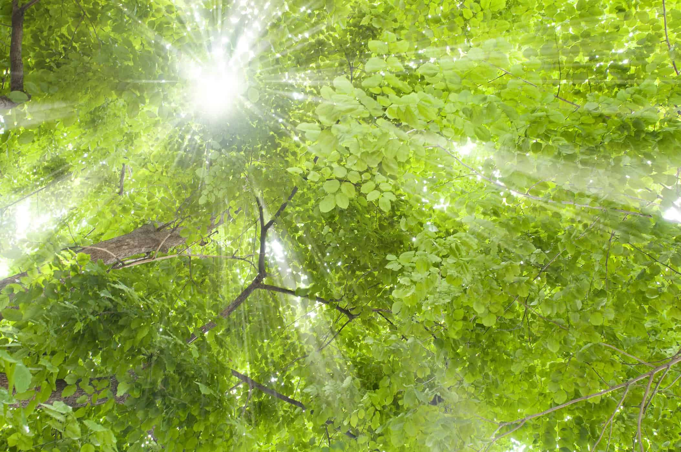

Lets plants fascinate you!

